**"Get Started with Power BI”**

**A Practical Data Analytics Guide**

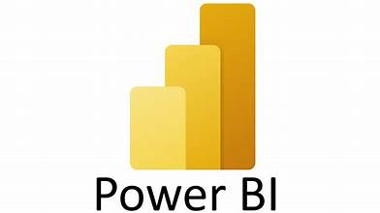

**"Empowering decision-makers with the right tools is essential for success. Power BI equips them with the insights needed to make strategic choices."**



**"Get Started with Power BI”**

**A Practical Data Analytics Guide**

**POINTS OF DISCUSSION**

* Introduction and Setup
* Creating Visualizations
* Building Reports and Dashboards
* Publishing and Sharing

**Welcome to Your Power BI Journey!**

"Data is the new oil of the digital economy, fueling innovation and driving decisions that shape our world. As William Edwards Deming famously said, 'In God we trust; all others must bring data.' Welcome to 'Get Started with Power BI: A Practical Data Analytics Guide,' where we embark on a journey to harness the power of data.

In this guide, you'll uncover the essentials of Power BI, a leading tool in the realm of business intelligence and data analytics. From connecting to diverse data sources to crafting compelling visualizations, you'll learn how to transform raw data into actionable insights.

Join us as we delve into the art of data modeling, building insightful reports and dashboards, and seamlessly sharing your discoveries with stakeholders. Whether you're new to data analytics or looking to refine your skills, this guide promises hands-on learning and practical knowledge to elevate your understanding of Power BI.

***Let's empower ourselves with data-driven decision-making and unlock the potential of Power BI together!"***



**EXPERIMENT NUMBER – 1**

**INTRODUCTION AND SETUP**

**TASKS**

* **Overview of Power BI**

Introduction to Power BI and its components (Power BI Desktop,

Power BI Service)

* **Installation and Setup**
  + - * Installing Power BI Desktop
      * Overview of the interface
      * Activity: Install Power BI Desktop and explore the interface.

**OVERVIEW OF POWER BI**

**Introduction to Power BI and its Components**

Power BI is a business analytics tool by Microsoft that provides interactive visualizations and business intelligence capabilities with an interface simple enough for end users to create their own reports and dashboards.

**The main components of Power BI are:**

1. **Power BI Desktop**: A Windows application for creating reports and data visualizations.
2. **Power BI Service**: An online SaaS (Software as a Service) where you can publish and share reports created in Power BI Desktop.

**INSTALLATION AND SETUP**

**Installing Power BI Desktop**

Follow these detailed steps to install Power BI Desktop:

1. **Download Power BI Desktop**:
   * Go to the [Power BI website](https://powerbi.microsoft.com/desktop/).
   * Click on the **"Download free"** button.
   * This will redirect you to the Microsoft Store or a direct download link.
2. **Install Power BI Desktop**:
   * If redirected to the Microsoft Store, click **"Get"** to download and install the application.
   * If you have a direct download link, download the installer file (.exe), and once the download is complete, open the file to start the installation.
   * Follow the on-screen instructions to complete the installation. You may need administrative rights to install software on your computer.
3. **Launch Power BI Desktop**:
   * Once installed, launch Power BI Desktop from your Start menu or desktop shortcut.

**OVERVIEW OF THE INTERFACE**

Upon opening Power BI Desktop, you will see several key areas:

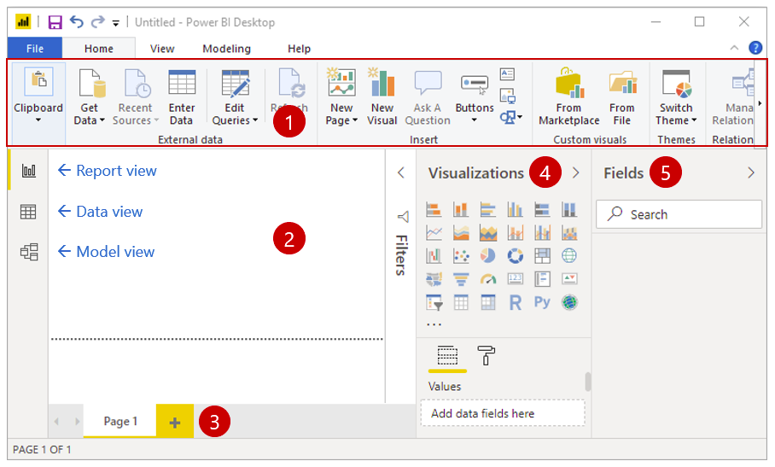

1. **Ribbon**: At the top, similar to other Microsoft Office applications, containing various tabs like *Home, View, Modeling*, etc.
2. **Report View**: The main area where you create and arrange visualizations.
3. **Data View**: Allows you to see your data in tabular form.
4. **Model View**: Used to manage relationships between tables in your data model.
5. **Fields Pane**: Displays the tables and fields in your data model.
6. **Visualizations Pane**: Contains various types of charts and graphs you can add to your report.
7. **Filters Pane**: Allows you to apply filters to your visualizations and data.

**Activity: Install Power BI Desktop and Explore the Interface**

1. **Installation**:
   * Follow the steps outlined above to download and install Power BI Desktop.
2. **Exploration**:
   * **Open Power BI Desktop**.
   * Familiarize yourself with the Ribbon by clicking through each tab and noting the different options available.
   * In the Report View, try dragging a field from the Fields Pane onto the Report View area to create a simple visualization.
   * Switch to the Data View and explore how your data looks in tabular form.
   * Use the Model View to see if there are any relationships between tables in your data model.
   * Experiment with different visualizations from the Visualizations Pane.
   * Apply filters using the Filters Pane and see how it affects your visualizations.

**DOWNLOAD, INSTALL AND UPGRADE FEATURES IN POWERBI**

**TASKS:**

* **Overview of Power BI**
  + Introduction to Power BI and its components

(Power BI Desktop, Power BI Service)

* **Installation and Setup**
  + Installing Power BI Desktop
  + Overview of the interface
  + Activity: Install Power BI Desktop and explore the interface

**AIM**

The aim of this experiment is to familiarize users with the process of downloading, installing, and upgrading Power BI Desktop, ensuring they have the necessary software installed and up-to-date to begin creating reports and visualizations effectively.

**OBJECTIVES**

* **Download and Install Power BI Desktop:**
  + Learn how to download the latest version of Power BI Desktop from the ***official Microsoft website.***
  + Understand the steps required to install Power BI Desktop on your computer, ensuring a successful installation process.
* **Upgrade Power BI Desktop:**
  + Learn how to check for ***updates and upgrade to the latest version*** of Power BI Desktop, ensuring access to new features and improvements.
* **Verify Installation and Compatibility:**
  + Verify that Power BI Desktop has been successfully installed and is ready for use by launching the application and exploring its interface.
  + Ensure compatibility with other Power BI components or services, such as Power BI Service, to enable seamless collaboration and data sharing.
  + By completing these objectives, users will be equipped with the necessary knowledge and skills to download, install, and upgrade Power BI Desktop, enabling them to leverage its powerful features for data analysis and visualization.

**PROCEDURE:**

#### **Step-1: Download Power BI Desktop**

1. Visit the official Microsoft Power BI Desktop download page using the following link: [Power BI Desktop Download](https://powerbi.microsoft.com/en-us/desktop/).**( https://www.microsoft.com/en-us/power-platform/products/power-bi/desktop)**
2. Click the **"Download"** button to get the latest version of Power BI Desktop.
3. Follow the prompts to save the installer file to your computer.

#### **Step-2: Install Power BI Desktop**

1. Locate the downloaded installer file (usually in your Downloads folder).
2. Double-click the **installer file** to begin the installation process.
3. Follow the on-screen instructions to complete the installation.

#### **Step-3: Check for Feature Upgrades**

1. Open Power BI Desktop by clicking the **application** icon.
2. From the taskbar, click on the **"File"** option.
3. Select **"Options and Settings"** from the dropdown menu.
4. Click on **"Options".**

#### **Step-4: Enable Preview Features**

1. In the Options window, select ***"Preview Features".***
2. Review the available features and check the ones you want to enable.
3. Click ***"OK"*** to apply the changes.

#### **Step-5: Restart Power BI Application**

1. Close Power BI Desktop.
2. Reopen Power BI Desktop to ensure all enabled features are visible and functional.

**STEP BY STEP PROCESS**

**Step-1** : Download **Power-BI - Desktop** from Microsoft Store using the following link :

<https://powerbi.microsoft.com/en-us/desktop/>.

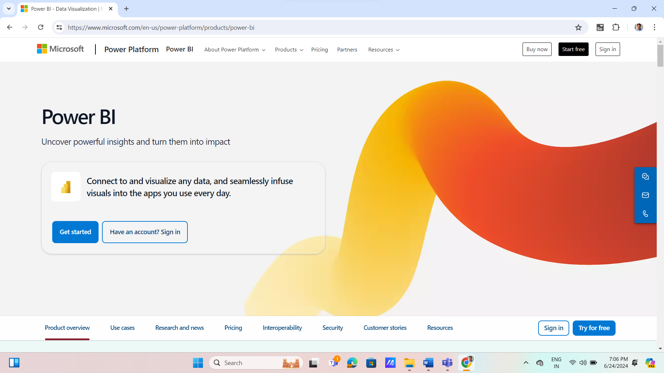

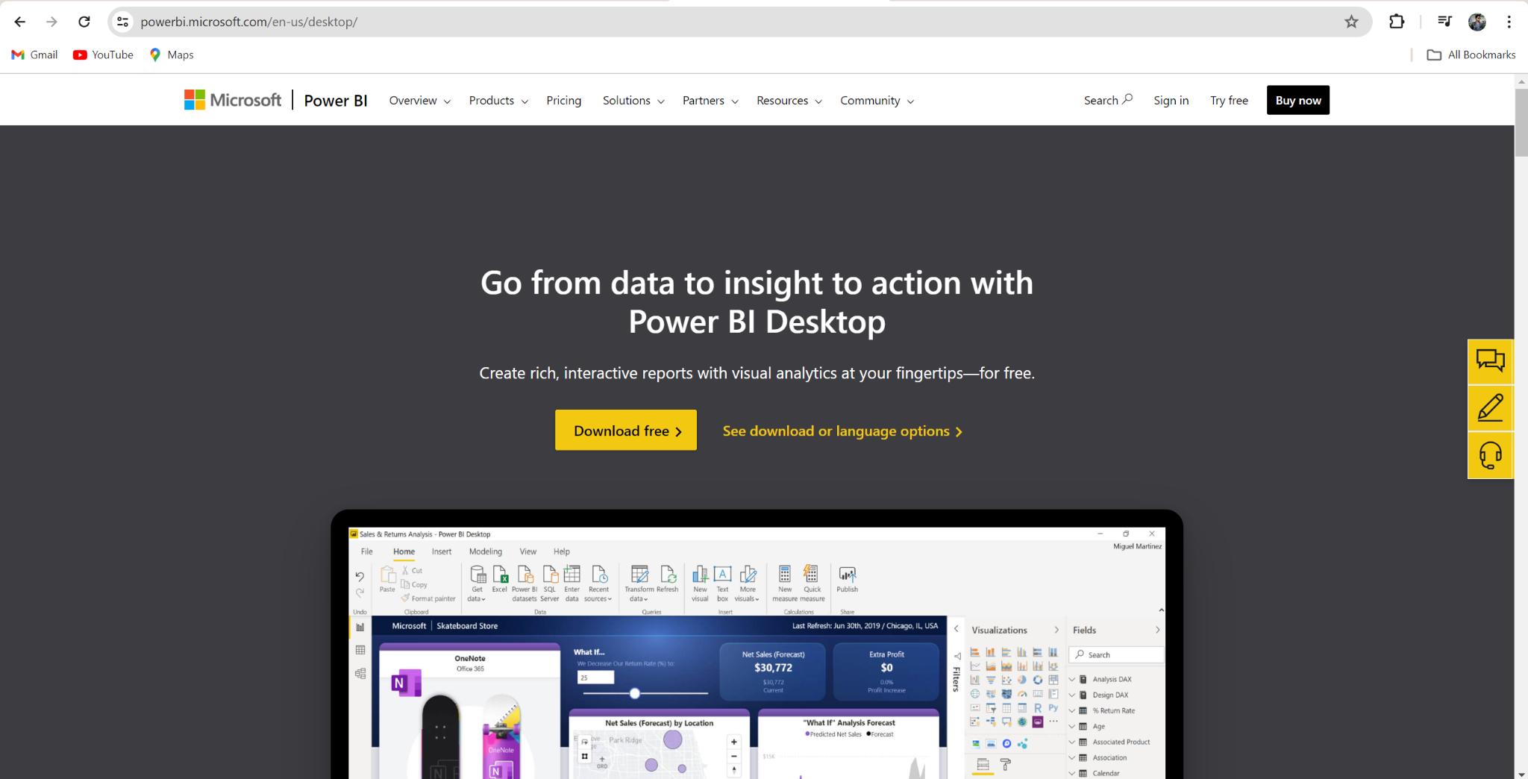

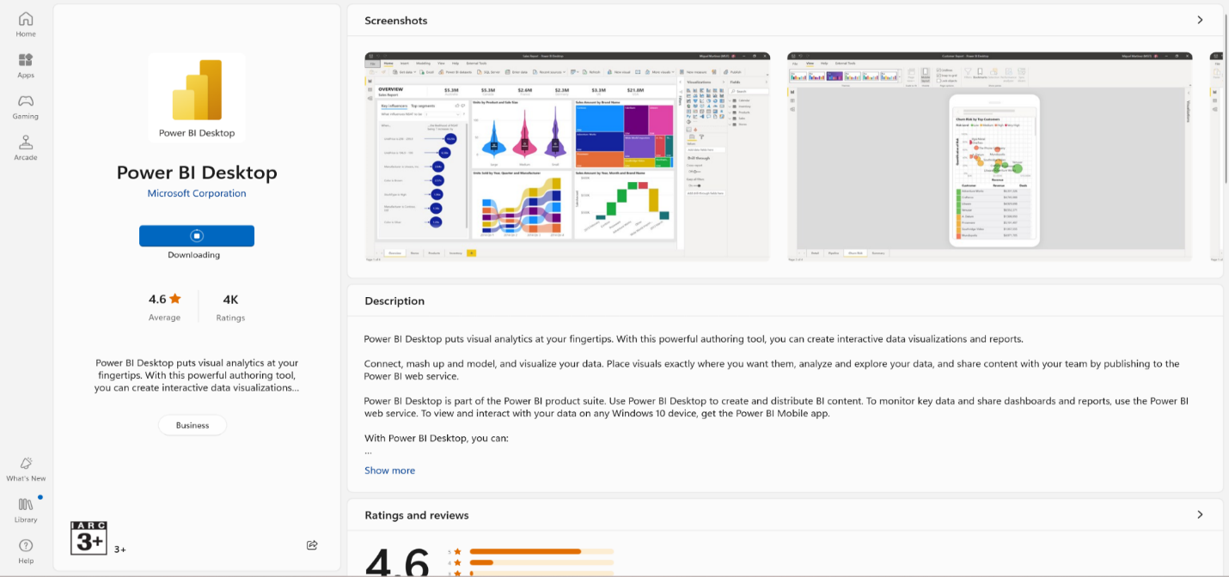

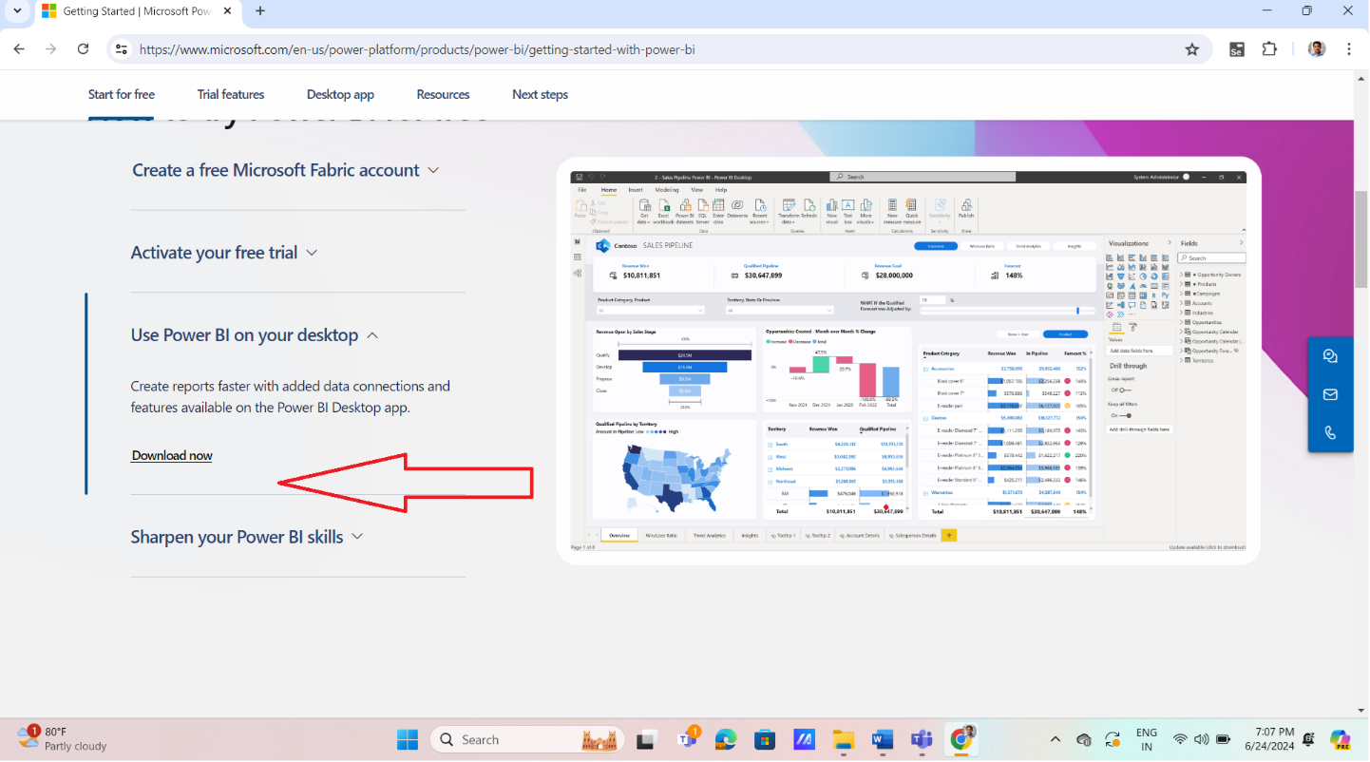

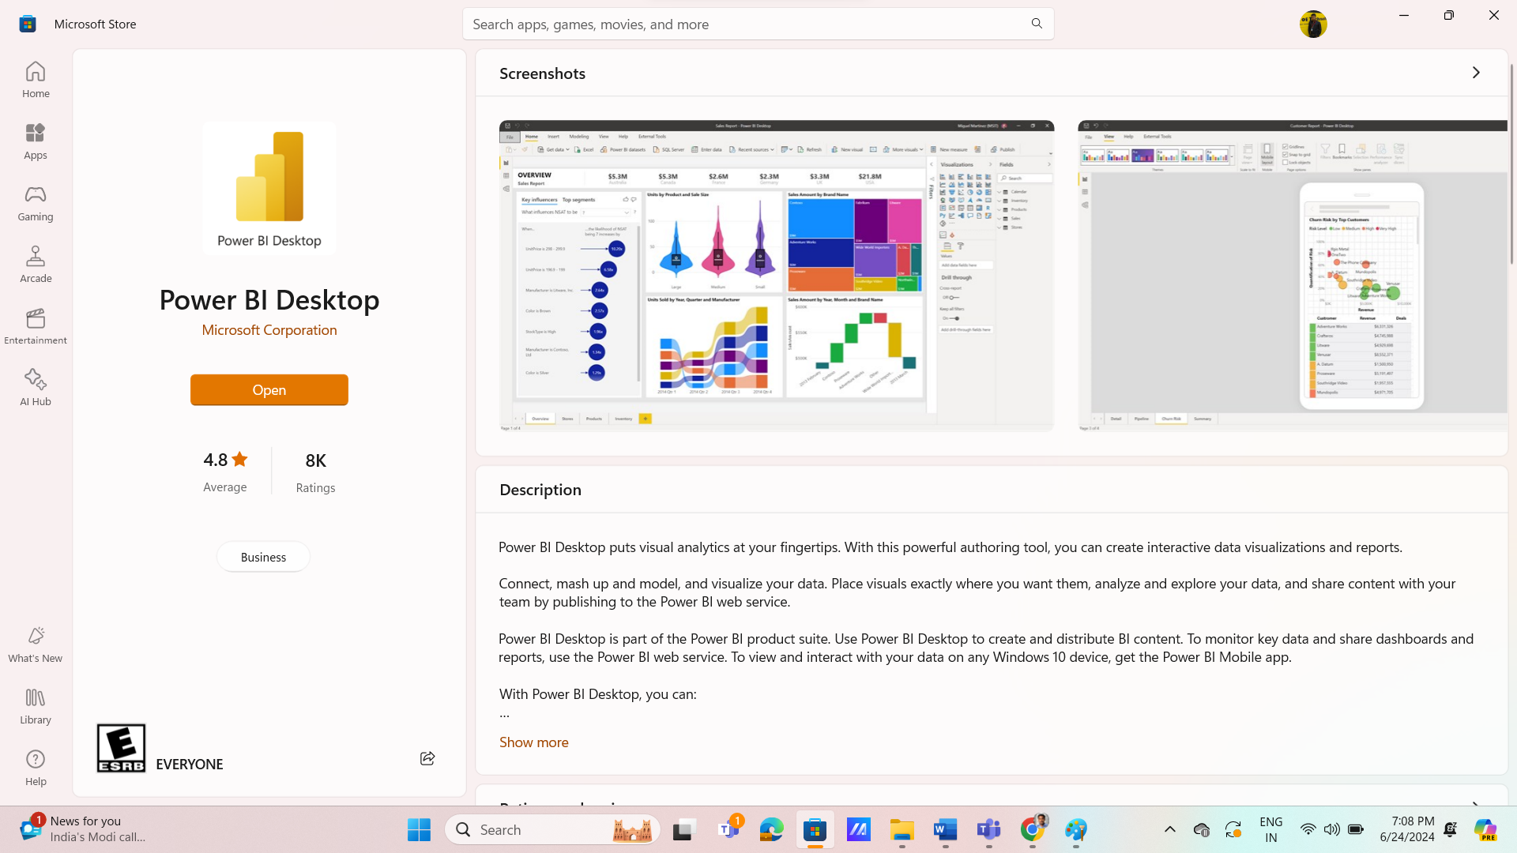

**Step-2:** Check for feature upgrades by clicking on **File** option from the **Task Bar** > Select **Options** **and** **Settings** option from the drop-down menu followed by selecting the **Options** item.

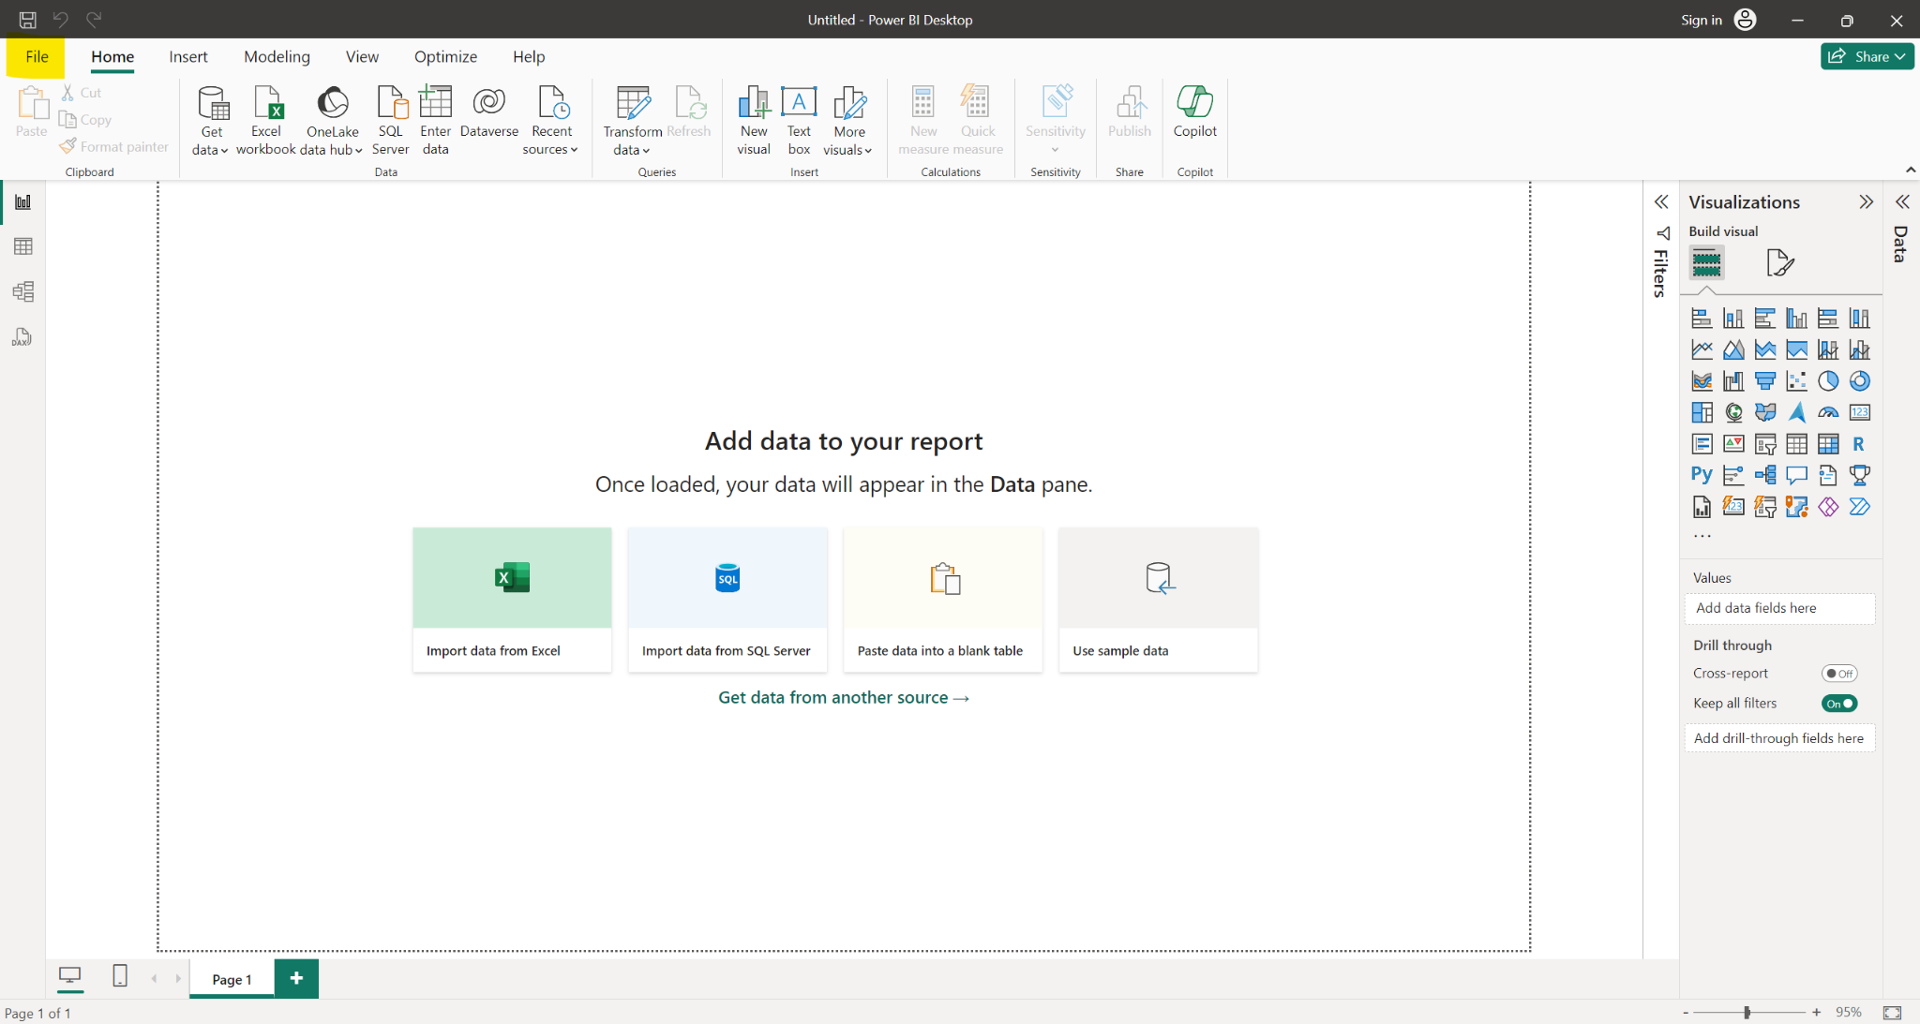

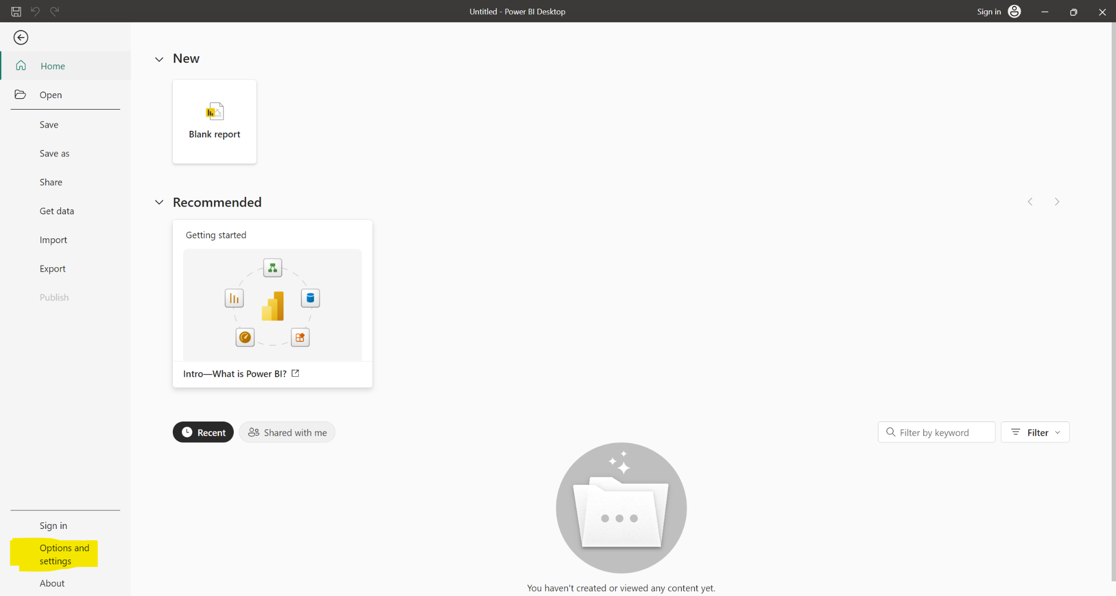

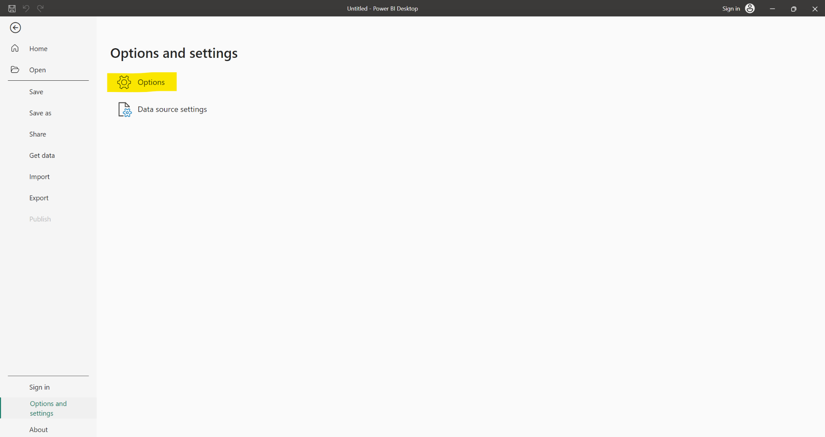

**Step-3** : From the options window select **Preview Features** option.

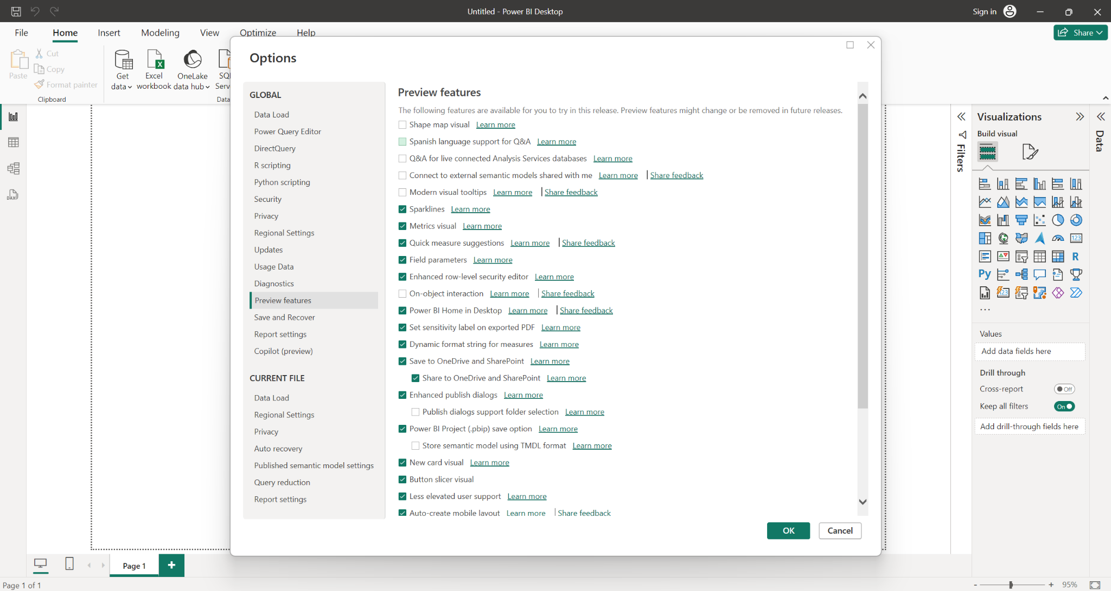

**Step-4:** Select the **additional features** you require and **click** on ok. These features should be checked regularly for constant upgrades from Microsoft.

**Step-5: Restart** the PowerBI Application for all the features to be visible on the application.

**KEY POINTS**

* Power BI is a business analytics tool by Microsoft.
* The main components are Power BI Desktop and Power BI Service.
* Follow the detailed steps to download, install, and explore Power BI Desktop.
* Regularly check for updates and enable new features to keep your software current.
* Familiarize yourself with the Power BI Desktop interface for efficient data analysis and visualization.

**CHAPTER SUMMARY**

In this experiment, we learned how to download, install, and upgrade Power BI Desktop. By following the outlined procedure, users can ensure they have the latest version of Power BI Desktop installed, with all the necessary features enabled for optimal performance. This knowledge is essential for effectively utilizing Power BI Desktop for data analysis and visualization tasks, allowing for seamless integration with other Power BI services and components.

**EXPERIMENT NUMBER – 1**

**CASE STUDY REPORT ON CYBERSECURITY THREATS**

**ANALYTICS USING POWER BI**

**Cybersecurity Threats**

This case study focuses on analyzing cybersecurity threat metrics from various sectors. Using data from the provided dataset, we will evaluate incident occurrences, threat vectors, system vulnerabilities, and response time variances. Data visualization tools will help generate insights for optimizing cybersecurity resources, improving threat detection, and identifying potential areas of improvement in both preventive and responsive security measures.

**AIM**  
The aim of this case study is to:

* Analyze cybersecurity incidents in terms of frequency and severity.
* Track system vulnerabilities and the effectiveness of security protocols.
* Compare the variance in threat occurrences against anticipated security benchmarks.
* Use data visualization techniques to present actionable insights through various charting methods.

**PROCEDURE**  
To analyze the data and generate reports:

1. **Load the Data:** Import cybersecurity data from the provided Excel file.
2. **Data Cleaning:** Clean and transform the data, ensuring correct data types and addressing missing or inconsistent data points.
3. **Create Relationships:** Establish relationships between different data tables if applicable.
4. **Apply Visualizations:** Use appropriate charts and graphs to visually represent threat patterns, vulnerabilities, and response metrics.
5. **Analysis and Insights:** Interpret the data to identify trends, high-risk areas, and provide strategic recommendations for threat mitigation.

**FUNCTIONS USED**

The following functions will be used in Power BI to manipulate the data and create visualizations:

1. **Data Loading**: To load and prepare the dataset from Excel or other data sources.
2. **Data Transformation**: Functions like ***Remove Duplicates, Fill Down, and Filtering for cleaning the data.***
3. **Visualization Functions**: To create various charts such as:

* **Table**
* **Bar chart**
* **Decomposition tree**
* **Tree map**
* **Multi row card**
* **Pie chart**
* **Line chart**
* **Donut chart**
* **Card**
* **Clustered bar chart**
* **Funnel**
* **Slicer**
* **Stacked column chart**

**Conditional Formatting**: To apply different colors based on conditions in charts like Heat Maps, Bar Charts, etc.

**WORKING STEPS**

**Step 1: Load Data into Power BI**

1. Open **Power BI Desktop**.

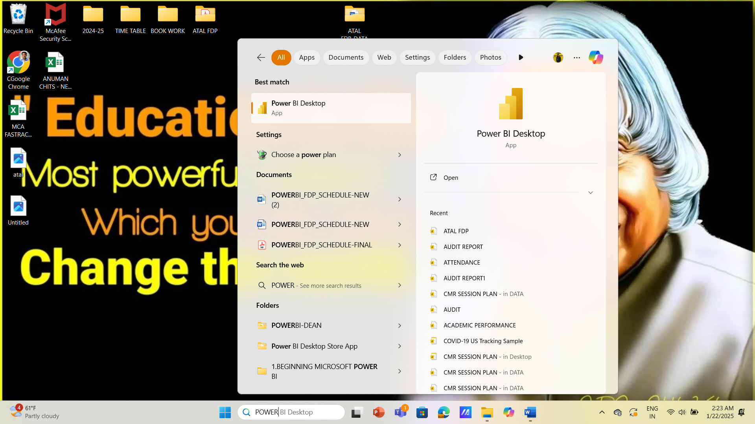

1. Click on **Home** > **Get Data** > **Excel** (or select another data source if applicable).

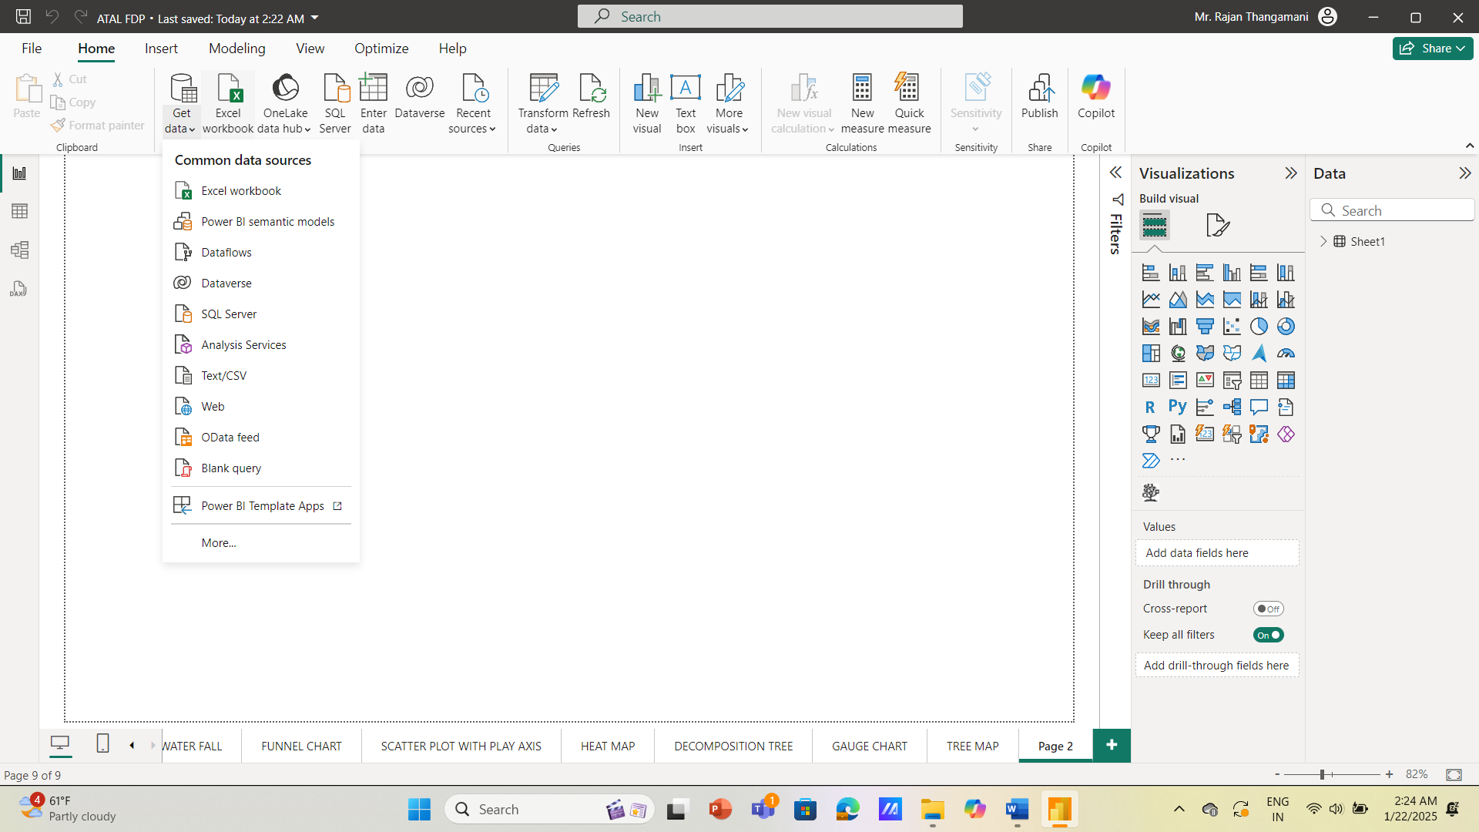

1. Choose the file containing the dataset with the necessary fields

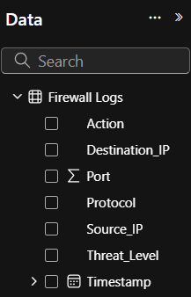

1. Select the required sheet and click **Load** to bring the data into Power BI

**Step 2: Data Preparation and Cleaning**

1. **Transform Data**:
   * 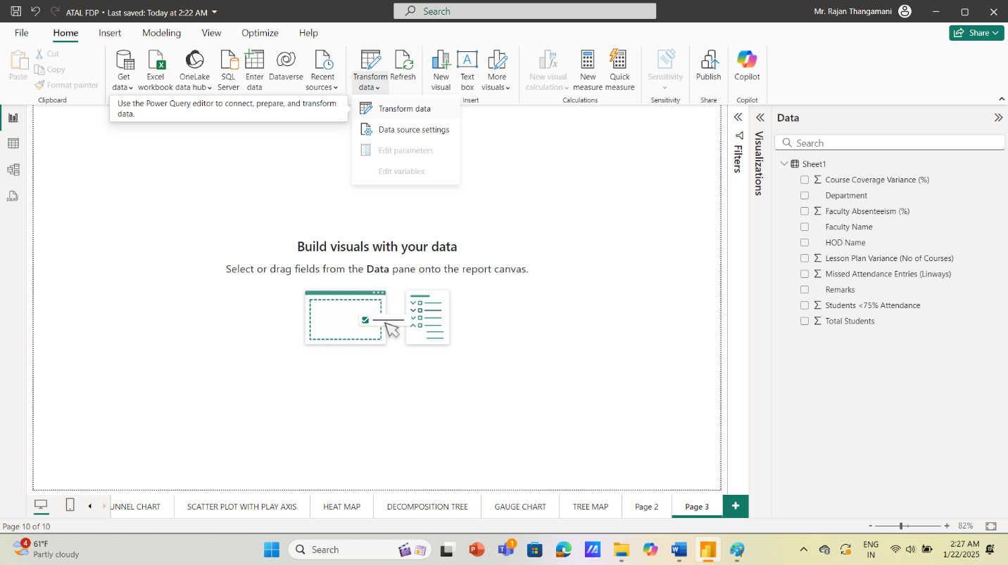Click **Transform Data** to open the Power Query Editor.

* Remove any duplicate entries or empty rows

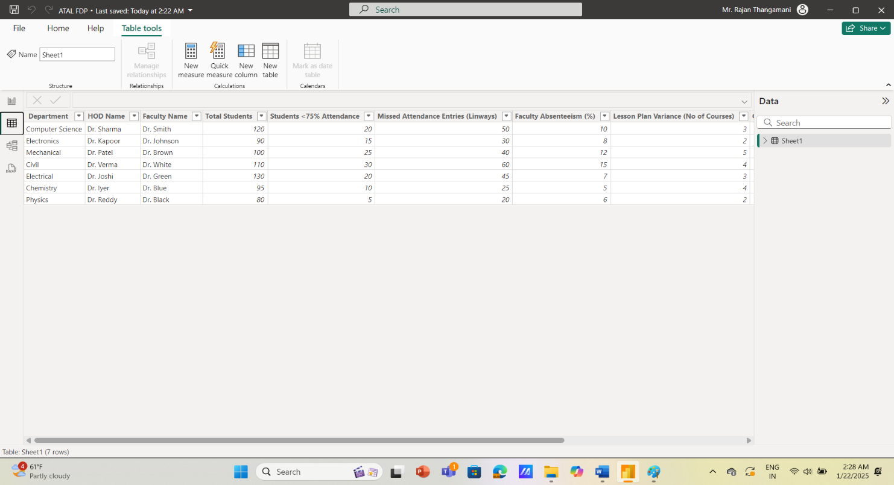

* Make sure the data types are correct

1. **Check for Missing Data**:
   * Identify missing values using filters or conditional formatting in the Power Query Editor.
   * Handle missing data by either filling values or removing rows as necessary.

**Step 3: Create Visualizations in Power BI**

Each of the following visualizations is created by dragging and dropping fields from the dataset into Power BI’s **Visualizations pane**.

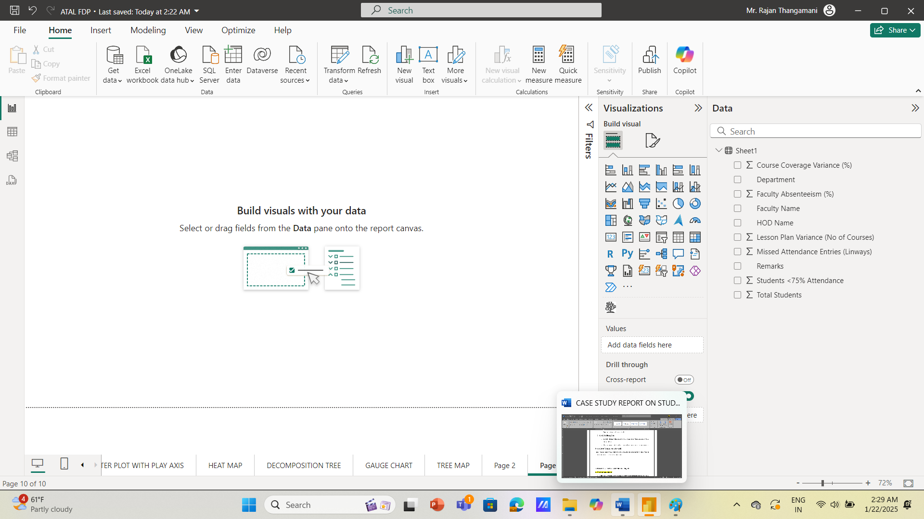

**POWER BI VISUALIZATIONS AND TECHNIQUES**

* 1. **Table**
* Definition: A Table chart is used to organize and display data in rows and columns, making it easy to compare and analyze multiple variables simultaneously.
* Purpose: It is ideal for presenting detailed cybersecurity threat data, such as incident types, frequency, severity levels, and response times, in a clear and structured format.
* Relevance: It helps in tracking and comparing different cybersecurity threats, vulnerabilities, and mitigation measures, providing a comprehensive overview of system security metrics for better decision-making.

**POWER BI PROCEDURE:**

1. **Select the Table Chart from the Visualizations pane.**
2. **Drag and drop Total Cybersecurity Incidents into the Values field.**
3. **Add High-Risk Threats to the Rows field for categorization.**
4. **Set Threat Type or Department Affected as the Column field to compare data across different categories.**

**INSIGHTS:**

* Identify which departments or systems are most affected by cybersecurity threats, contributing to overall security vulnerabilities.
* The Table Chart can clearly show how each threat category or department contributes to the increase or decrease in cybersecurity risks, making it easier to compare and analyze threat impact.

**Experiment 1: Cybersecurity Data Visualizations**

**Exercise1.1: Table Chart - Threat Overview**

**Visualization Name:** Table Chart Purpose: Displays structured data in rows and columns for easy readability.

**Steps to Create:**

1. Select the Table Chart visualization.

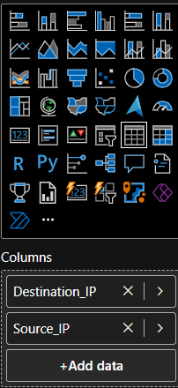

1. Drag relevant fields such as Threat Type, Frequency, and Impact into the table.
2. Adjust column widths and sorting options.

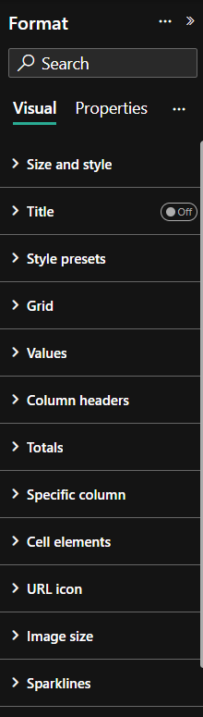

1. Apply formatting for readability.
2. Save and analyze the data.

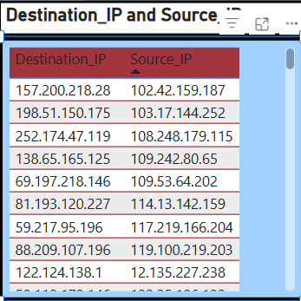

**Exercise 1.2: Bar Chart - Threat Distribution**

**Visualization Name:** Bar Chart Purpose: Used to compare the frequency of different cybersecurity threats over time.

**Steps to Create:**

1. Select the Bar Chart visualization.

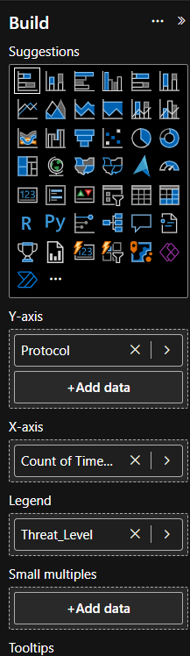

1. Drag Threat Type to the X-axis.
2. Drag Frequency of Threats to the Y-axis.
3. Apply sorting and formatting for clarity.

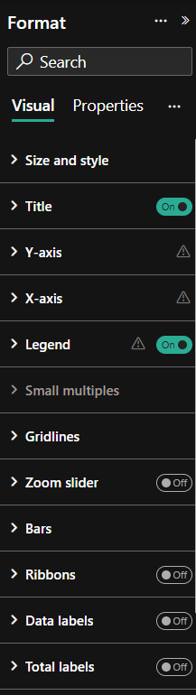

1. Customize labels, colors, and titles.
2. Save and analyze trends.

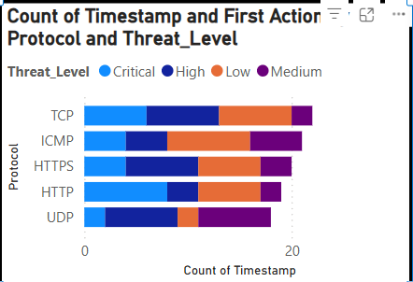

**Exercise 1.3: Decomposition Tree - Threat Analysis**

**Visualization Name:** Decomposition Tree Purpose: Breaks down complex threat data into hierarchical components.

**Steps to Create:**

1. Select the Decomposition Tree visualization.

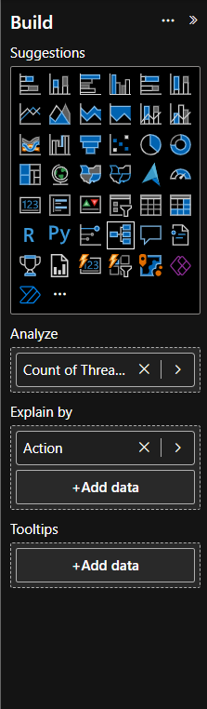

1. Drag Threat Category as the root.
2. Add Threat Subcategories to decompose the data further.
3. Apply filters and drill down for in-depth insights.

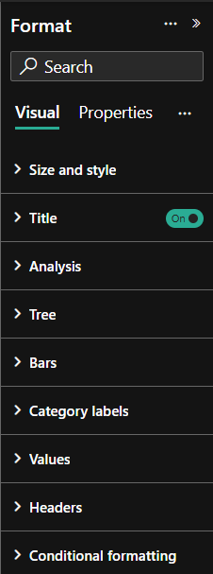

1. Save and interpret the breakdown.

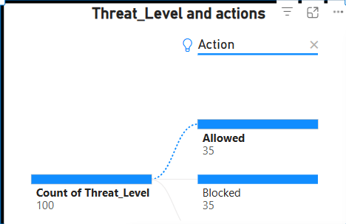

**Exercise 1.4: Card - Key Threat Indicator**

**Visualization Name: Card Purpose**: Highlights a single key metric such as the total number of incidents.

**Steps to Create:**

1. Select the Card visualization.

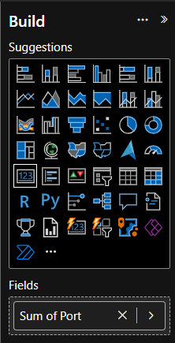

1. Assign Total Incidents as the value.
2. Format the text size and background.

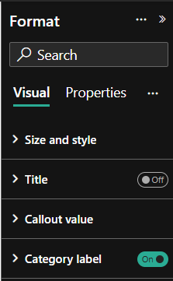

1. Save and display the key metric.

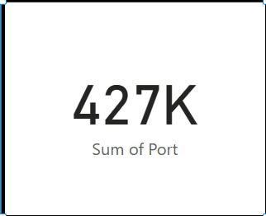

**Exercise 1.5: Treemap - Threat Categories Breakdown**

**Visualization Name: Treemap Purpose:** Displays hierarchical data to show threat distribution by category.

**Steps to Create:**

1. Select the Treemap visualization.

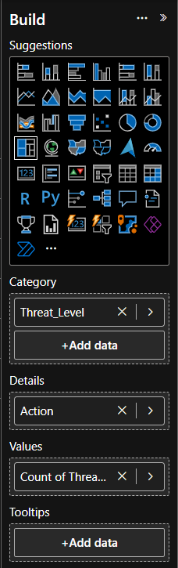

1. Assign Threat Category to the group field.
2. Assign Incident Count to values.
3. Customize the size and color schemes.
4. Format labels for better readability.

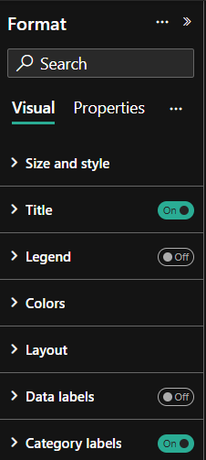

1. Save and interpret insights.

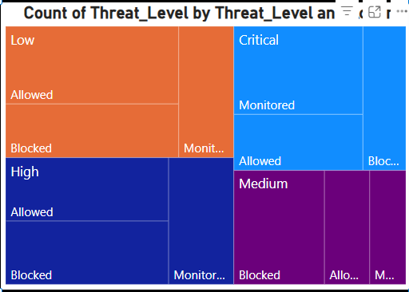

**Exercise 1.6: Multi-Row Card - Multiple KPIs**

**Visualization Name:** Multi-Row Card Purpose: Displays multiple key performance indicators (KPIs) at once.

**Steps to Create:**

1. Select the Multi-Row Card visualization.
2. Assign multiple key values such as Threat Count, Response Time, and Impact Level.

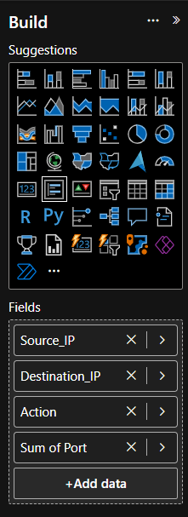

1. Customize formatting and layout.

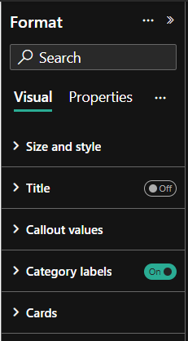

1. Save and review key performance indicators.

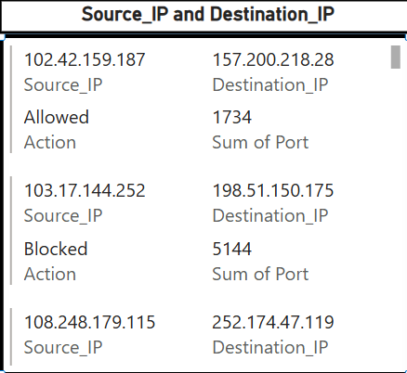

**Exercise 1.7: Pie Chart - Proportion of Threats by Type**

**Visualization Name:** Pie Chart Purpose: Helps visualize the proportion of different cybersecurity threats.

**Steps to Create:**

1. Select the Pie Chart visualization.
2. Drag Threat Type to the legend.
3. Drag Incident Count to values.

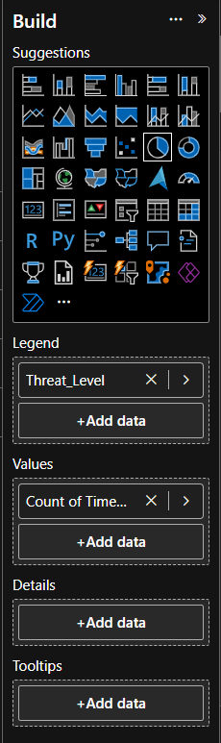

1. Adjust the colors for better distinction.
2. Enable percentage labels for clarity.

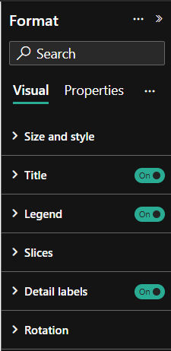

1. Save and review the insights.

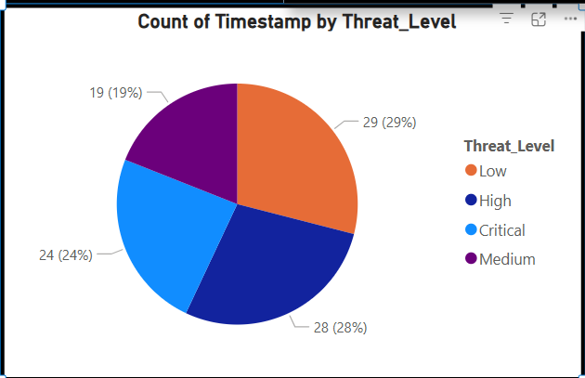

**REPORT 1**

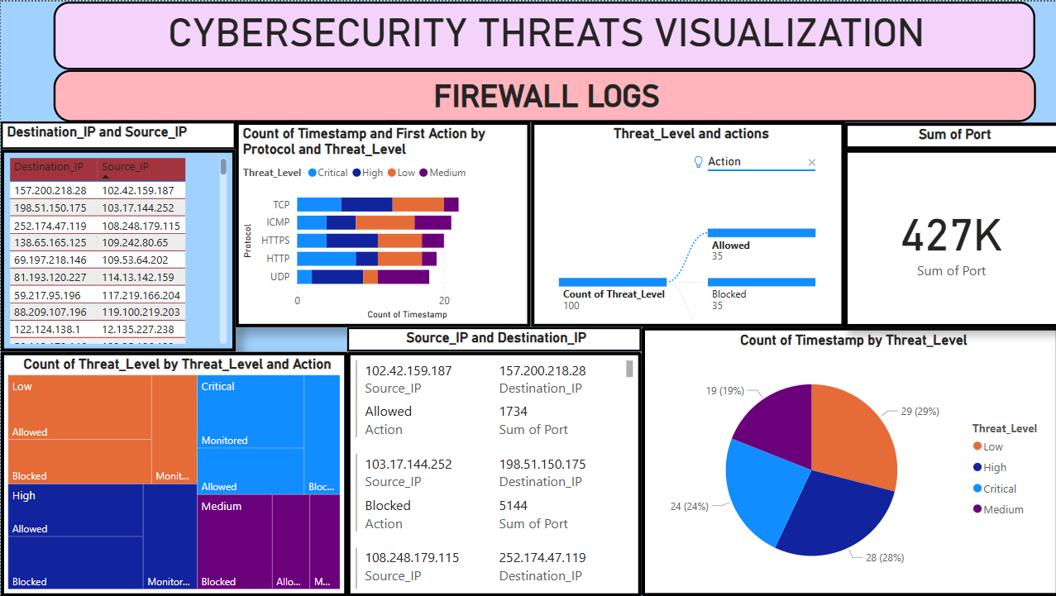

**Experiment 2: Cybersecurity Data Visualizations**

**Exercise 2.1: Scatter Plot - Alert Type by Severity**

**Visualization Name:** Scatter Plot Purpose: Displays the relationship between alert type and severity to identify trends in cybersecurity incidents.

**Steps to Create:**

1. Select the Scatter Plot visualization.

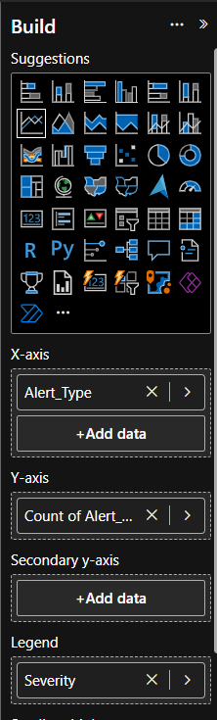

1. Drag Alert Type to the X-axis.
2. Drag Count of Alert Type to the Y-axis.
3. Use Severity Level as the legend for color differentiation.

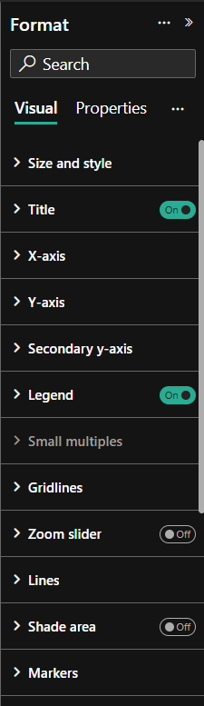

1. Adjust labels and formatting.
2. Save and analyze the threat trends.

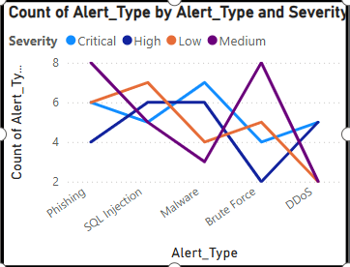

**Exercise 2.2: Donut Chart - Alert Type by Severity**

**Visualization Name:** Donut Chart Purpose: Represents the proportion of alerts categorized by severity levels.

**Steps to Create:**

1. Select the Donut Chart visualization.

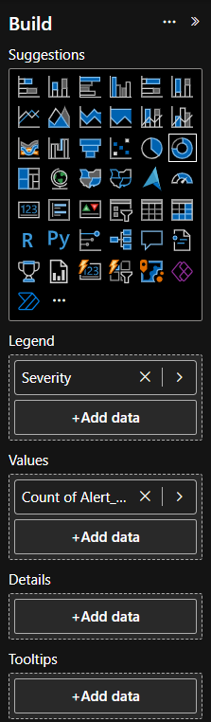

1. Drag Alert Type to the legend field.
2. Drag Count of Alert Type to values.
3. Use Severity Level for color distinction.
4. Format the chart with labels and percentage values.

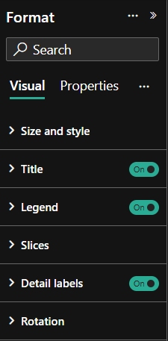

1. Save and interpret the data proportions.

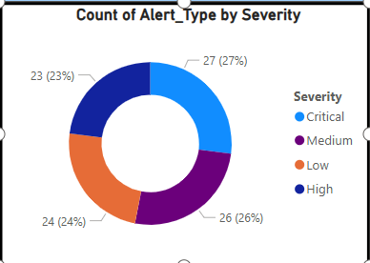

**Exercise 2.3: Card - First Destination IP Address**

**Visualization Name: Card Purpose:** Highlights a key metric, displaying the first recorded destination IP address.

**Steps to Create:**

1. Select the Card visualization.
2. Drag First Destination_IP to the value field.

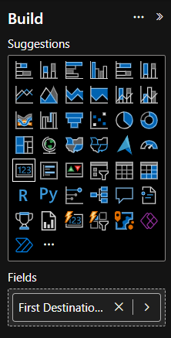

1. Format the text size and background for clarity.

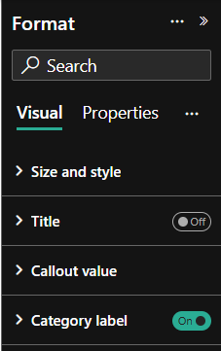

1. Save and monitor the displayed IP address.

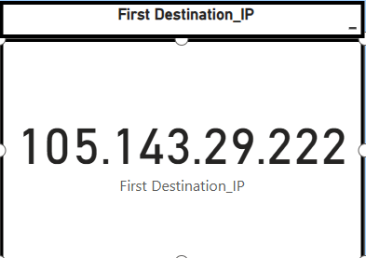

**Exercise 2.4: Stacked Bar Chart - Source IP Count by Alert Type and Severity**

**Visualization Name: Stacked Bar Chart Purpose:** Shows the number of incidents by source IP, categorized by alert type and severity.

**Steps to Create:**

1. Select the Stacked Bar Chart visualization.

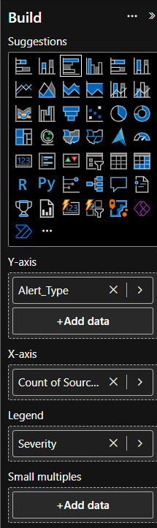

1. Assign Alert Type to the Y-axis.
2. Assign Count of Source IP to the X-axis.
3. Use Severity Level as the legend to differentiate categories.
4. Format labels and colors for clarity.

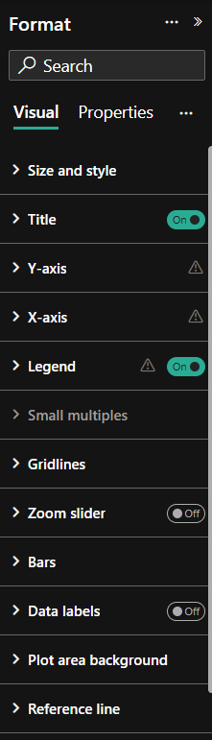

1. Save and analyze threat trends.

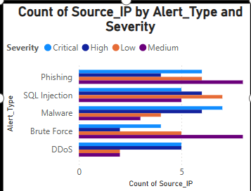

**Exercise 2.5: Bar Chart - Severity Count by Alert Type**

**Visualization Name: Funnel Chart Purpose:** Displays the number of incidents for each alert type categorized by severity.

**Steps to Create:**

1. Select the Bar Chart visualization.
2. Drag category as in the image.
3. Drag values as in the image.

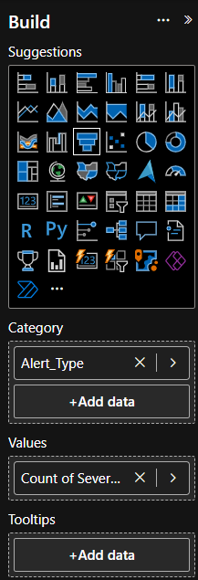

1. Use Severity Level for color distinction.
2. Format the chart with labels and colors.

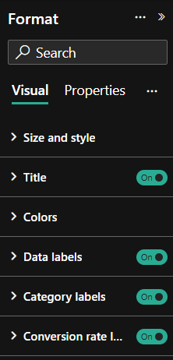

1. Save and interpret the alert type severity distribution.

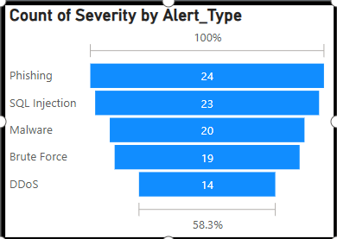

**Exercise 2.6: Slicer - Category Filter**

**Visualization Name: Slicer Purpose:** Allows users to filter data by alert type categories, enhancing interactive analysis.

**Steps to Create:**

1. Select the Slicer visualization.
2. Drag Alert Type into the slicer field.

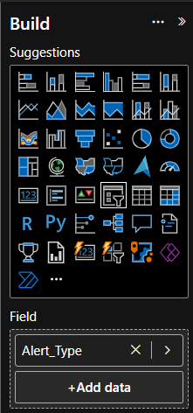

1. Adjust the format for better usability.

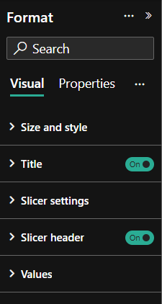

1. Save and enable interactive filtering.

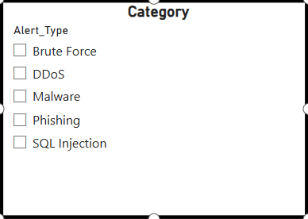

**REPORT 2**

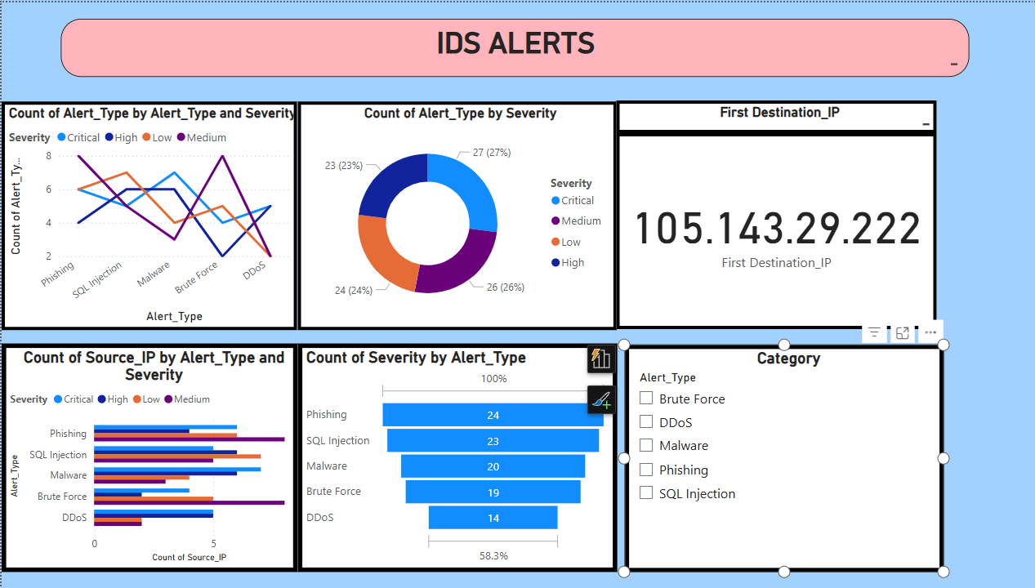

**Experiment 3: Cybersecurity Data Visualizations**

**Exercise 3.1:Card (Single Value Display) – First Destination IP**

**Purpose:** Displays the first destination IP from the dataset.

**Steps to Create in Tableau/Power BI:**

1. **Add a Card (Power BI)**
2. **Drag the "Destination_IP" field** into the visual.

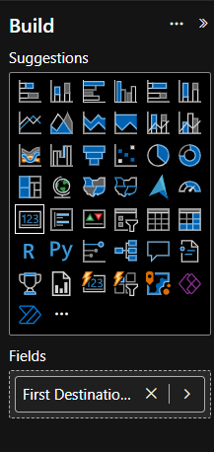

1. **Apply a sorting/filtering method** to display the first Destination IP.
   * Power BI: Use First(Destination_IP).

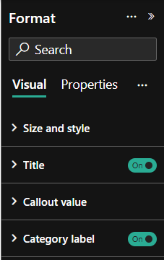

1. **Customize font size and alignment** for better visibility.

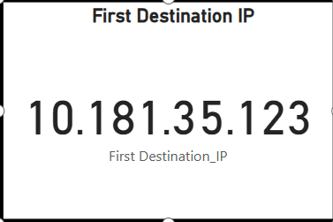

**Exercise 3.2: Column Chart – Sum of Packet Size Bytes by Source IP**

**Purpose:** Shows which source IPs contribute the most data traffic.

**Steps to Create:**

1. **Insert a Column Chart (Bar Chart).**
2. **Drag "Source_IP" to the X-axis.**
3. **Drag "Packet_Size_Bytes" to the Y-axis and set aggregation to SUM.**

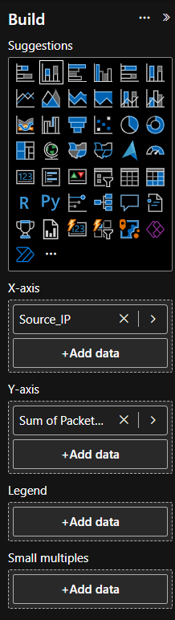

1. **Sort bars in descending order** to highlight top data senders.

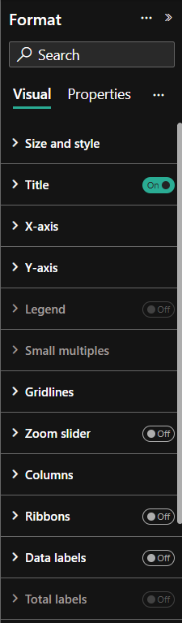

1. **Format labels and adjust axis scaling** for readability.

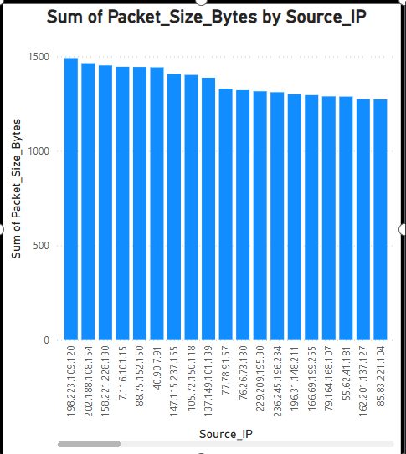

**Exercise 3.3: Pie Chart – Count of Destination_IP by Protocol**

**Purpose:** Shows the distribution of destination IPs based on network protocol.

**Steps to Create:**

1. **Insert a Pie Chart.**
2. **Drag "Protocol" into the legend/segment field.**
3. **Drag "Destination_IP" into values and set aggregation to COUNT.**

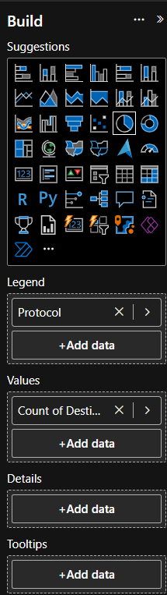

1. **Format labels to show percentages and values.**

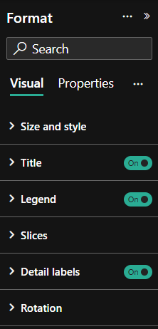

1. **Adjust color scheme for easy distinction between protocols.**

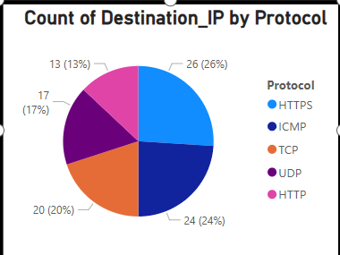

**Exercise 3.4: Table – Network Data Details**

**Purpose:** Provides a detailed breakdown of network activity with key metrics.

**Steps to Create:**

1. **Insert a Table (or Matrix in Power BI).**
2. **Add the following fields:**
   * Protocol
   * Destination_IP
   * Source_IP
   * Sum of Packet_Size_Bytes
   * Sum of Latency
   * Count of Status
   * Year, Quarter, Month

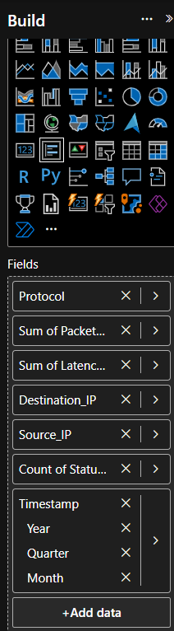

1. **Apply sorting and filtering** for easy navigation.

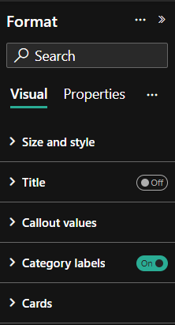

1. **Format columns for better readability (date formats, numeric precision, etc.).**

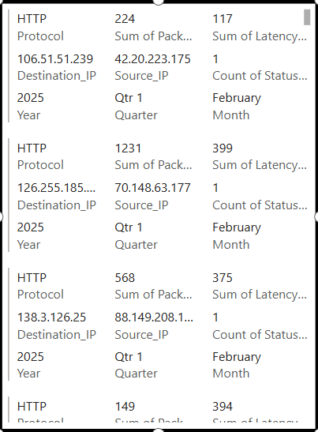

**REPORT 3**

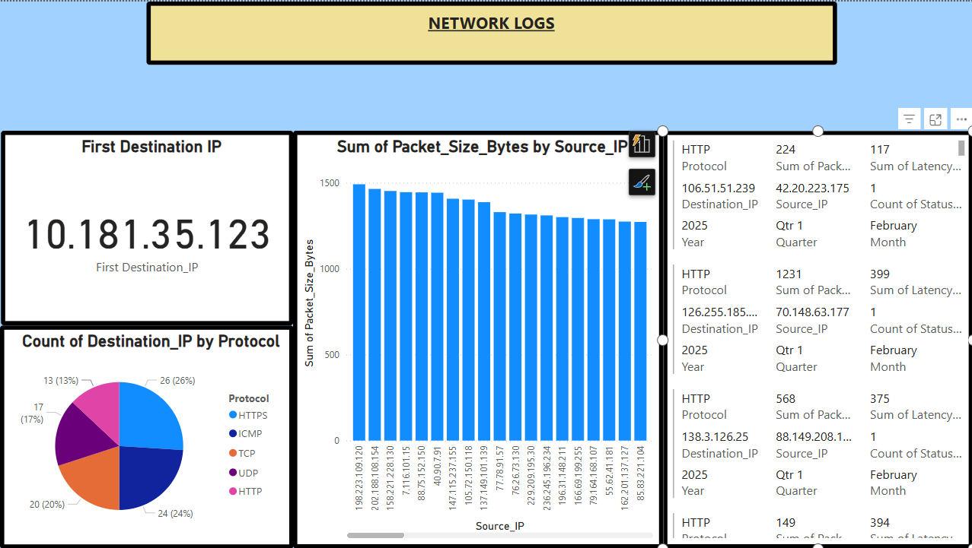

**Experiment 4: Cybersecurity Data Visualizations**

**Exercise 4.1: Bar Chart - Count of Threat Level by Threat Name**

**Visualization Name:** Bar Chart  
**Purpose:** Displays the frequency of different threat levels across various threat names. Helps in identifying the most common threats.

**Steps to Create:**

1. Select the **Bar Chart** visualization.
2. Drag **Threat Name** to the Y-axis.
3. Drag **Count of Threat Level** to the X-axis.

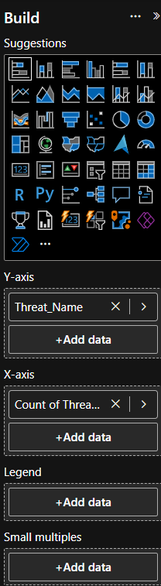

1. Apply appropriate formatting and color coding.

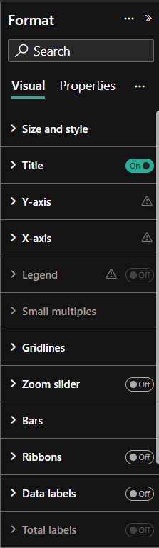

1. Save and analyze the common cybersecurity threats.

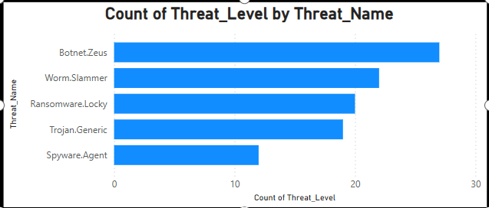

**Exercise 4.2: Pie Chart - Count of Threat ID by Threat Level**

**Visualization Name:** Pie Chart  
**Purpose:** Shows the proportion of threat IDs categorized by threat level. Useful for understanding the distribution of different threat severity levels.

**Steps to Create:**

1. Select the **Pie Chart** visualization.
2. Drag **Threat Level** to the legend field.
3. Drag **Count of Threat ID** to values.

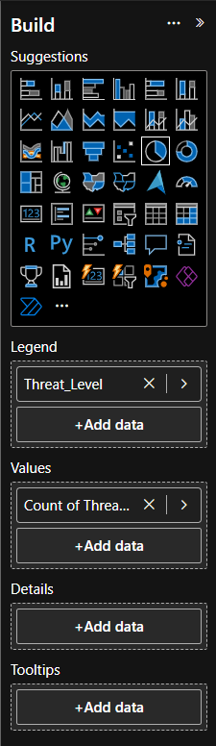

1. Format the chart with labels and percentage values.

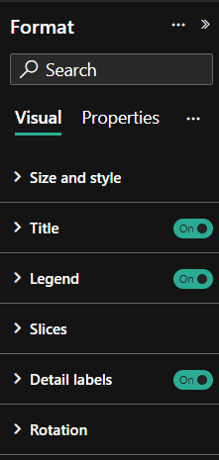

1. Save and interpret the threat level distribution.

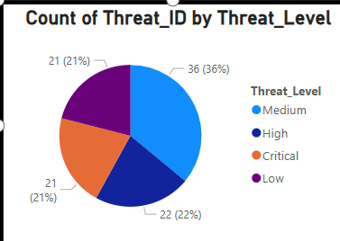

**Exercise 4.3: Funnel Chart - Threat Level Breakdown**

**Visualization Name:** Funnel Chart  
**Purpose:** Provides a hierarchical view of cybersecurity threats by level, allowing easy comparison of different severity levels.

**Steps to Create:**

1. Select the **Funnel Chart** visualization.
2. Drag **Threat Level** to the group field.
3. Drag **Count of Country** to values.

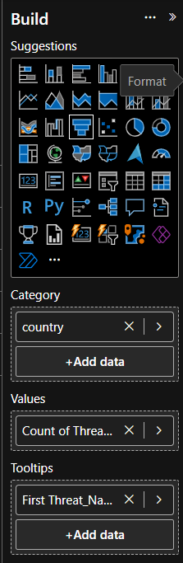

1. Adjust formatting for better readability.

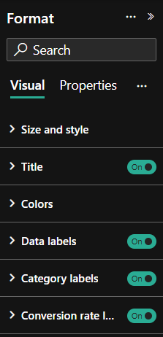

1. Save and analyze threat level distribution.

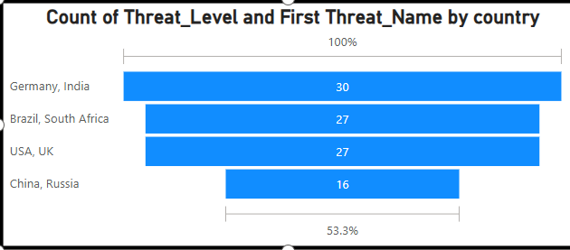

**Exercise 4.4: Decomposition Tree - Threat Level Analysis**

**Visualization Name:** **Decomposition Tree**  
**Purpose:** Helps break down threat levels by category, showing relationships and trends.

**Steps to Create:**

1. Select the **Decomposition Tree** visualization.
2. Drag **Threat Level** to the root field.
3. Drag additional breakdown fields such as **Country or Threat Name** for deeper insights.

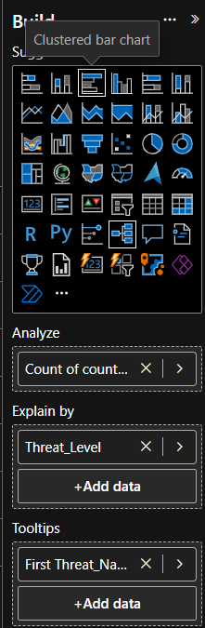

1. Customize formatting for clarity.

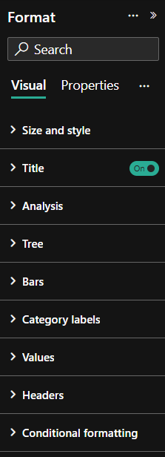

1. Save and interact with the visualization for detailed analysis.

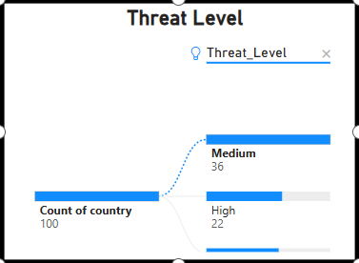

**Exercise 4.5: Card - First Threat Name**

**Visualization Name:** Card  
**Purpose:** Displays the first recorded cybersecurity threat name as a key metric.

**Steps to Create:**

1. Select the **Card** visualization.
2. Drag **First Threat Name** to the value field.

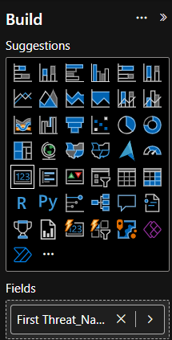

1. Adjust font size and background for visibility.

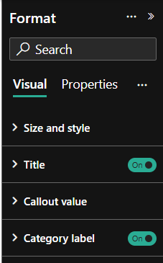

1. Save and monitor the displayed threat name.

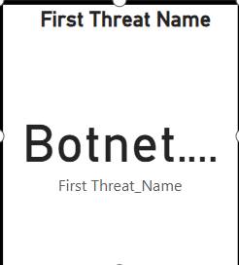

**Exercise 4.6: Table - Threat Data by Country and Threat Name**

**Visualization Name:** Table  
**Purpose:** Displays a detailed tabular representation of cybersecurity threats categorized by country.

**Steps to Create:**

1. Select the **Table** visualization.
2. Drag **Country** and **Threat Name** to the table columns.

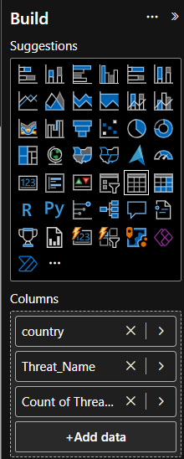

1. Apply sorting and formatting for readability.

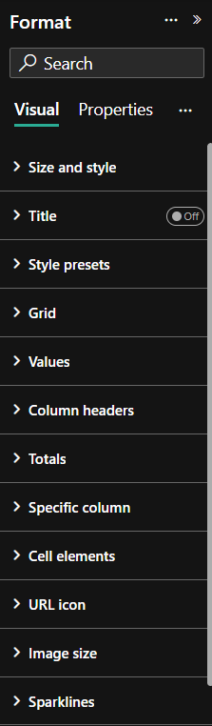

1. Save and use for data-driven cybersecurity analysis.

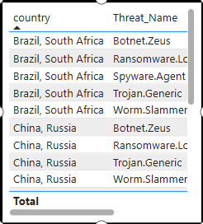

**REPORT 4**

